Title or Task: | Create a slide show in Flash  

Description:

Files Required
Suitable for Classes: | AIT • Multimedia • Cert II IT • Cert II Bus
Area: | Technology & Enterprise
Teacher: | Mr Peter Faulks

Timeline

Date Due:

Task Brief:

Outcomes:

Items highlighted in yellow are tasks for you to complete
Items in Purple are help tips

Create a slide show in Flash
Your task is to create a simple linear web page slide show about a gizmo multimedia device such as Mobile phone, Camera, etc.

Create a slide show in Flash using at least four pictures some text and special effects

Open Flash

Open flash click on Action Script 3.0

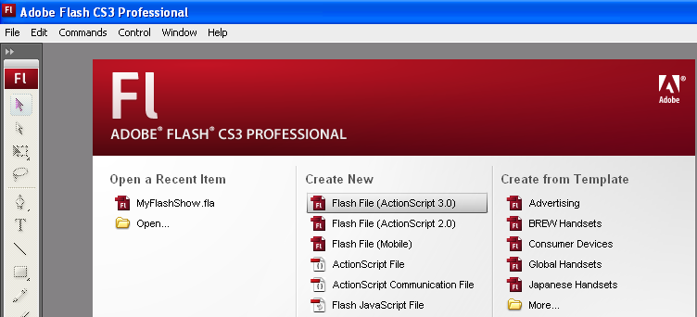

You will be shown this screen

Call this My Advert

Change the document size to 500px by 120px (px = points)
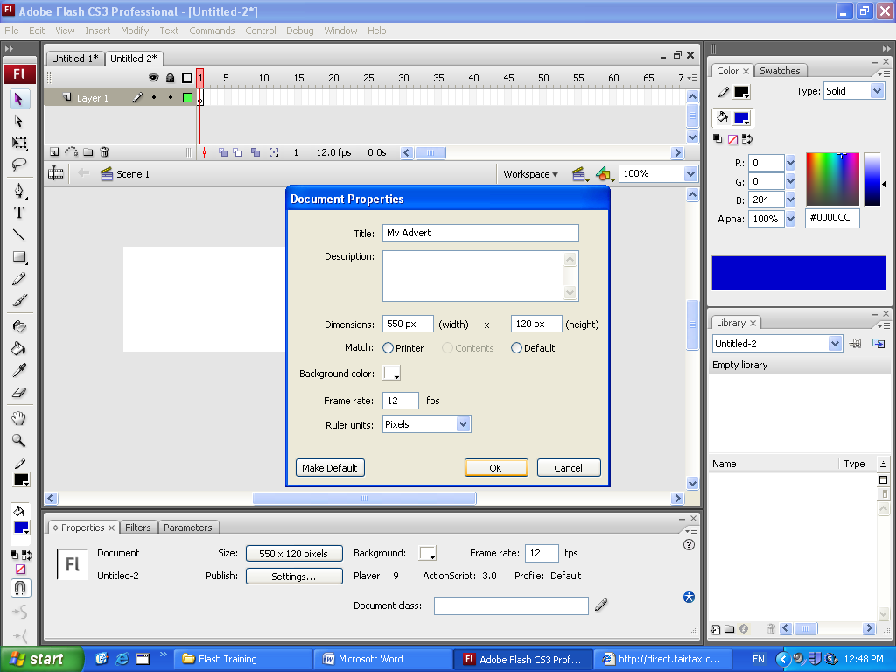

Gather at least four images from the internet on a web gizmo product of your choice

- Mobile Phone

- MP3 player with music plus movie/video playback
- DVD Player
- Blackberry device
- Bluray or DVD Recorder
- Portable entertainment system,
- LCD, LED or Plasma TV
- Surround sound system etc.
- Your choice

In photoshop resize these to 120 points height

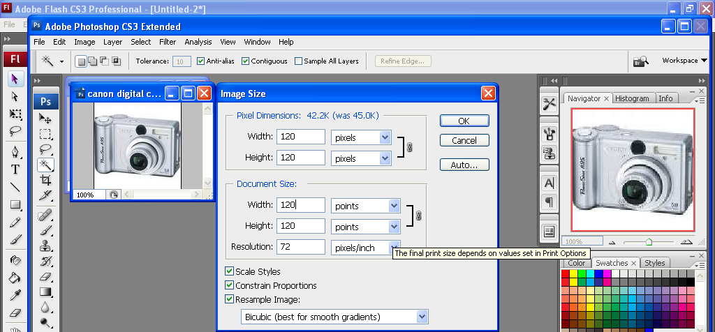

Modify the document so that all items fit (you may need to make this longer)

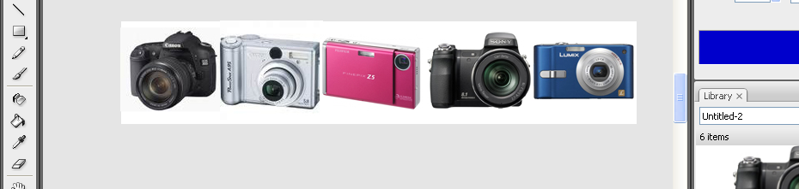

Now we can start our slide show production

Start with one of your objects this one is camera 1

Click on Modify - Convert to symbol and make this a graphic (call it item 1 or camera 1) 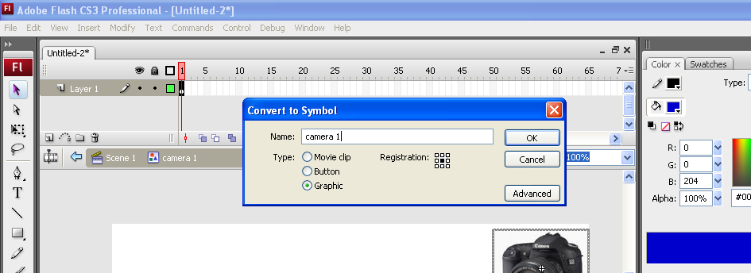

Set the brightness to 100 to make it disappear

Insert a keyframe to 30

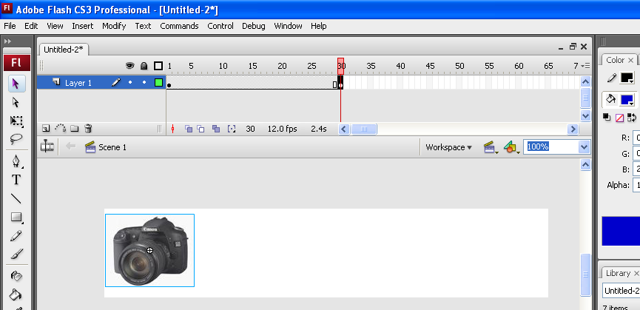

Then move it the object to the left as shown.

Set the Brightness back to normal so you can see your item

Click half way across your layer and insert Create a Motion Tween
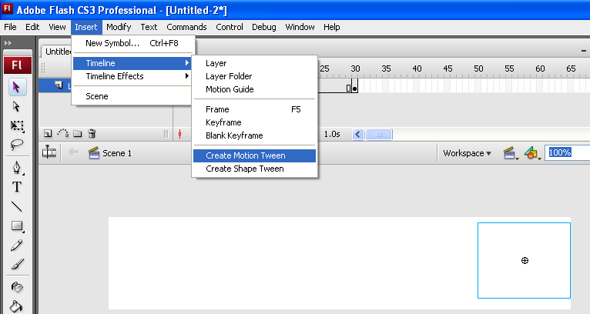

You should see this 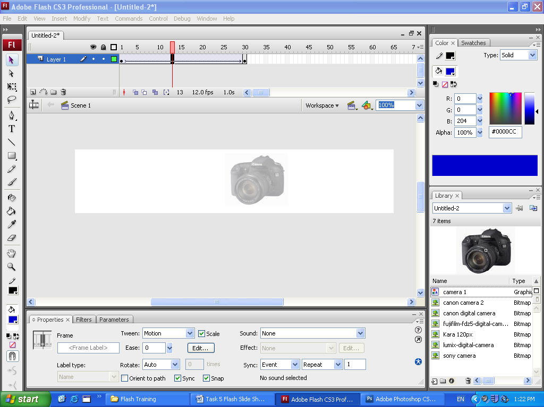

On a new layer bring in the next item and repeat the process until all items appear as a slide show.

Add your photo and make this rotate across the page

Add a Produced by banner that scrolls across the page

Add more effects the enhance your slide show

You do not have to copy this show

Here are some effects worksheets to help you become more creative.



